
12
11
10
9
8
7
6
5
4
3
2
1


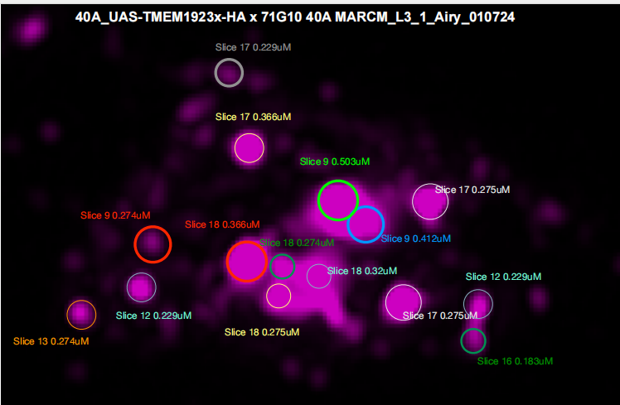

1)

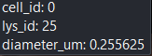 0.256 0.229 GOOD

2)
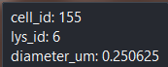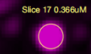0.251 0.366 NOT GOOD

3)
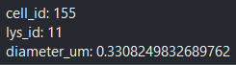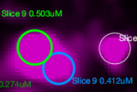
0.331 0.503, 0.412-AVG-0.4575 NOT GOOD

4)
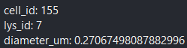 0.271 0.275 GOOD

5)
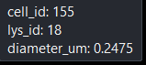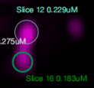0.248 (0.229,0.183)---->0.206 NOT GOOD

6)
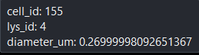 0.270 0.275 GOOD
7)

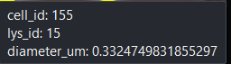 0.332 0.320 GOOD

8)
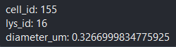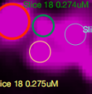 0.327 (0.274+0.275)--->0.2745 NOT GOOD

9)
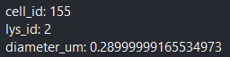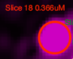0.290 0.366 NOT GOOD

10)

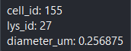0.257 0.274 GOOD

11)

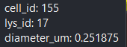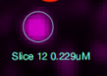0.252 0.229 GOOD

12)

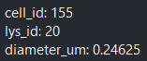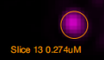0.247 0.274 GOOD

